**Zener diode**

* **Zener** diode is heavily doped than the normal p-n junction diode. Hence, it has very thin [depletion region](https://www.physics-and-radio-electronics.com/electronic-devices-and-circuits/semiconductor-diodes/depletion-region.html). Therefore, **zener** diodes allow more electric current than the normal p-n junction diodes.
* **Zener** diode allows electric current in forward direction like a normal diode but also allows electric current in the reverse direction if the applied reverse voltage is greater than the zener voltage.
* **Zener d**iode is always connected in reverse direction because it is specifically designed to work in reverse direction.
* A **zener** diode is a p-n junction semiconductor device designed to operate in the reverse breakdown region. The breakdown voltage of a zener diode is carefully set by controlling the doping level during manufacture.
* The name **zener** diode was named after the American physicist **Clarance Melvin Zener** who discovered the **zener effect.**
* **Zener** diodes are the basic building blocks of electronic circuits. They are widely used in all kinds of electronic equipments. Zener diodes are mainly used to protect electronic circuits from over voltage.

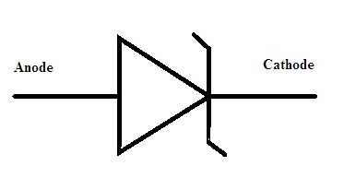

**Working principle of zener diode**

* Usually, the condition of the diode with basic p-n as its junction during reverse bias is that there is no chance of conduction because the depletion region width is comparatively high.
* As the applied reverse voltage tends to increase that result in the increment of the width of the depletion region. Even there exist some minority carriers which gain some energy because of increment of reverse voltage.
* Due to the gain in kinetic energy of the minority carriers, these free electrons in movement collide with the stationary ions. This results in the formation of more free electrons.
* Further, these again collide with remaining stationary ions and this process continues it is referred to as **carrier multiplication**.
* Because of carrier multiplication, a huge multiple of free electrons are created and the complete region of the diode becomes conductive resulting in the breakdown known as avalanche breakdown.
* Generally, this is not the case in the Zener diode. In Zener diode, the junction is doped with the highest concentration. Because of this reason when the reverse voltage has applied the width of the depletion region tends to minimize.
* As there exist the maximum concentration of the impure atoms in it. It creates the maximum number of ions in it.
* As soon as the diode exceeds the threshold value the electrons that are in the covalent bonds tend to come out in the depletion region so that it can make depletion region conductive.
* Hence this type of breakdown is referred to as [**Zener breakdown**](https://www.watelectronics.com/zener-breakdown-avalanche-breakdown-differences/)**.** The occurrence of this breakdown will be at certain voltage termed as **Zener voltage**.
* Just as cut in voltage in normal diode here it is **Zener** voltage. Once the applied voltage exceeds the value of voltage it tends to conduct.
* This value of the Zener voltage is properly adjusted at the time of manufacturing by the proper concentration in [**doping**](https://en.wikipedia.org/wiki/Doping_(semiconductor))**.**
* In case of occurring of break down further, there is no possibility of occurrence of avalanche breakdown.

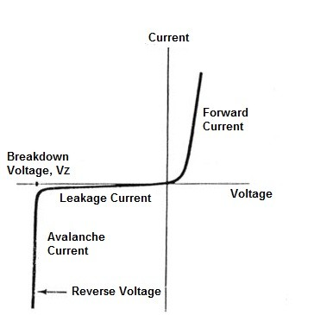

Zener diode characteristics curve

 During forward bias condition Zener diode characteristics will remain the same as that of the normal diode. Whereas after the applied voltage crosses the value of Zener voltage (Vz ) the Zener breakdown takes place. After the breakdown, the flow of the current in the circuit tends to increase immediately.

**Applications of Zener diode**

This diode has many applications such as −

* It is mostly used as a Voltage Regulator.
* Provides fixed reference voltage in transistor biasing circuits.
* For peak clipping or limiting in wave shaping circuits.
* As a Surge protector in many circuits.
* For meter protection against damage from accidental applications.